

**Discipline**

**Life Cycle Management**

**CS5002**

Activity-8

**Sheikh Muhammed Tadeeb (AU19B1014)**

* **Problem Statement:**

Create a Life rule to Move current object to:

1. Standard OneZone after 35 days. Then move the object to Glacier after 95 and delete the current object after 150 days.
2. For Previous object move it to glacier after 100 days and delete the object after 195 days.

* **Solution1)**

Step 1) Open the bucket on which we need to create the lifecycle-rule. Then go **management panel** and click on **Create Lifecycle Rule.**

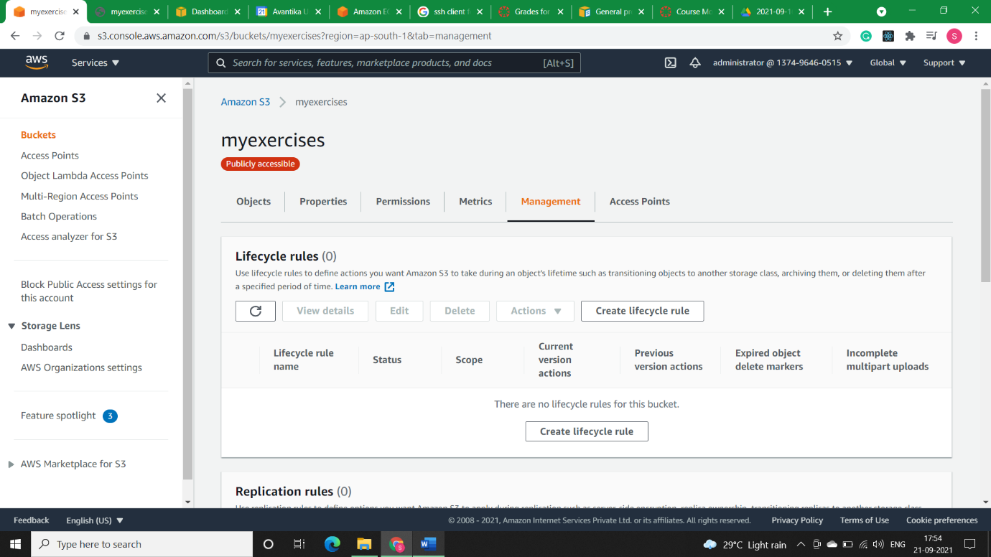

Step2) Give the name to the rule and apply it for the whole bucket and click on I acknowledge. Then select the rules for current version and specify them.

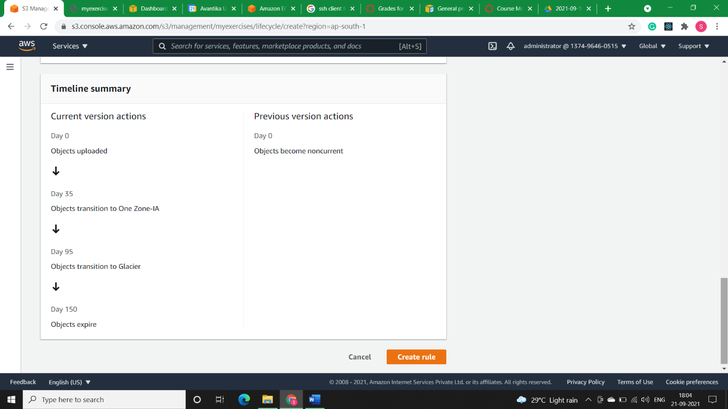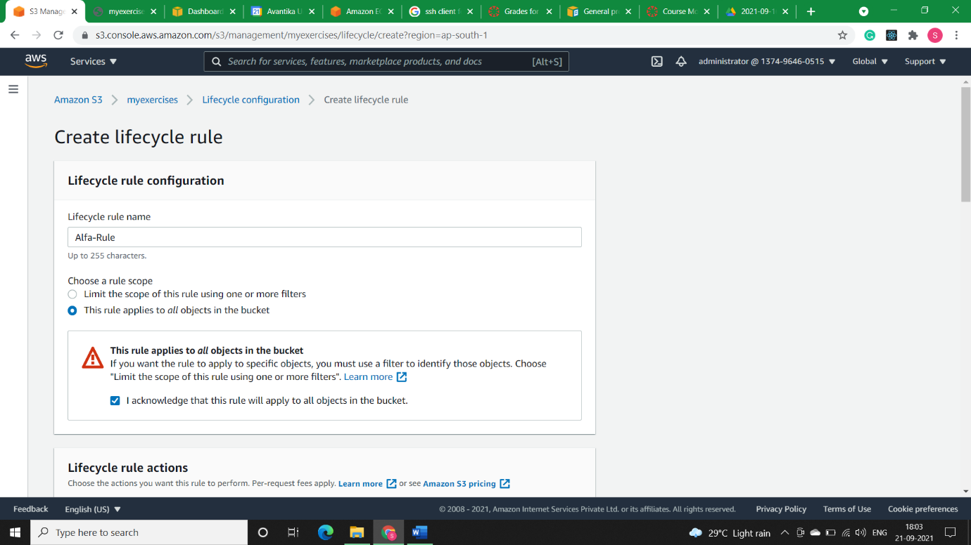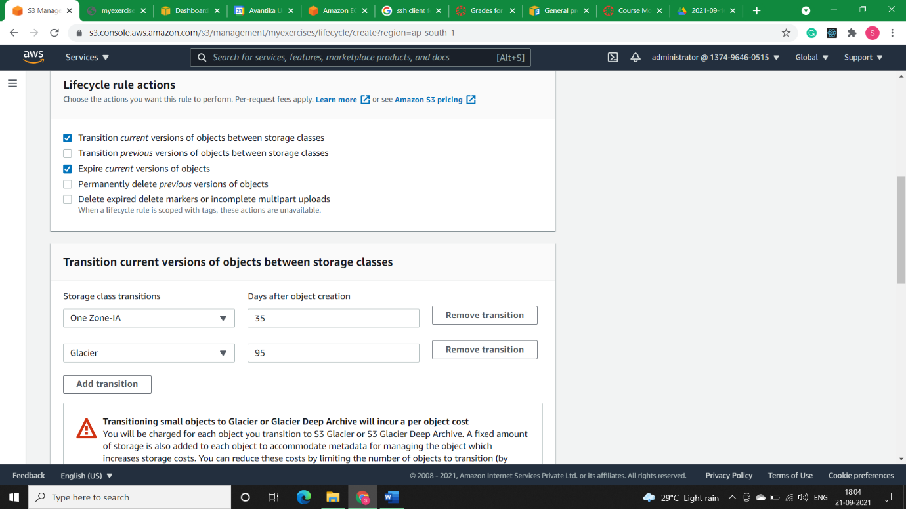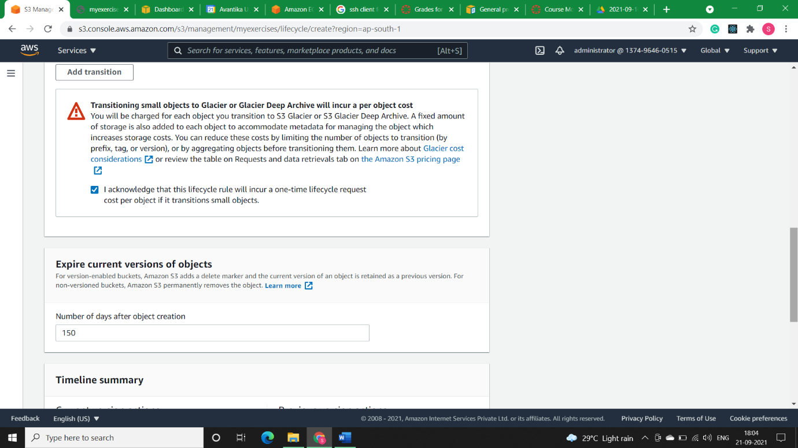

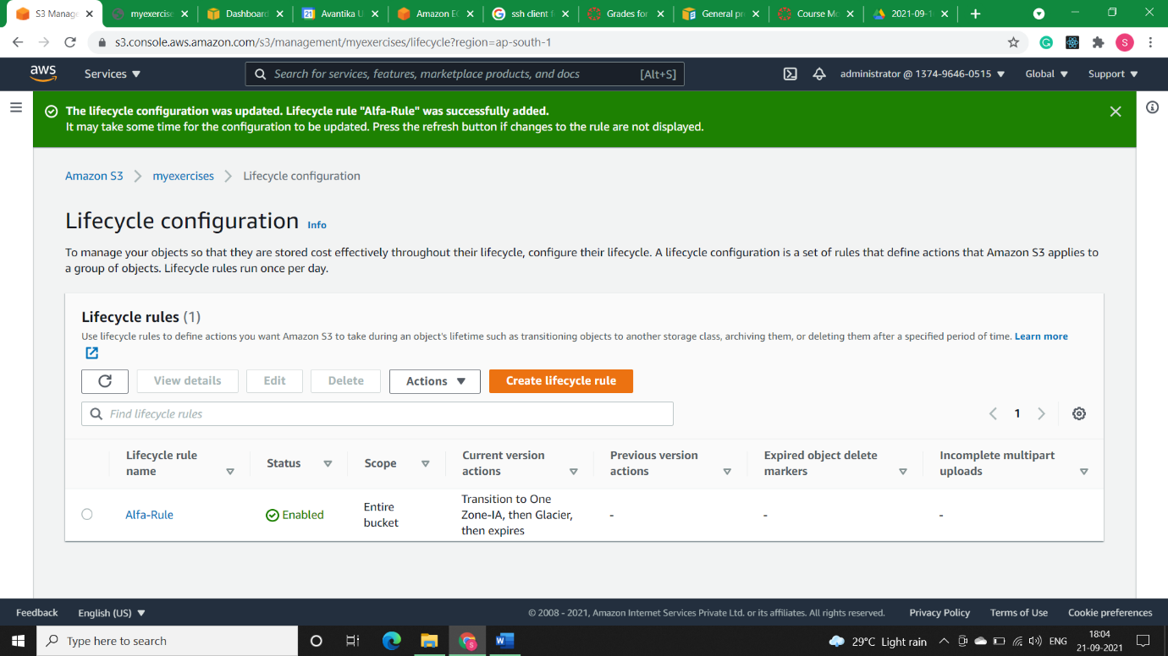

Note: We can see that the rule is successfully created with name Alfa-Rule.

* **Solution2)**

Step 1) Open the bucket on which we need to create the lifecycle-rule. Then go **management panel** and click on **Create Lifecycle Rule.**

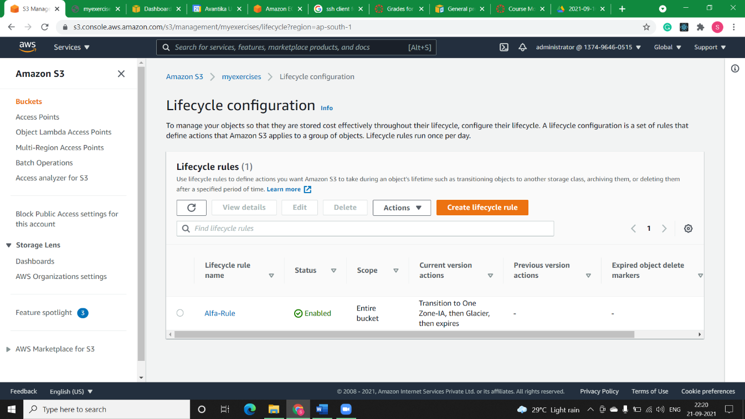

Step2) Give the name to the rule and apply it for the whole bucket and click on I acknowledge.

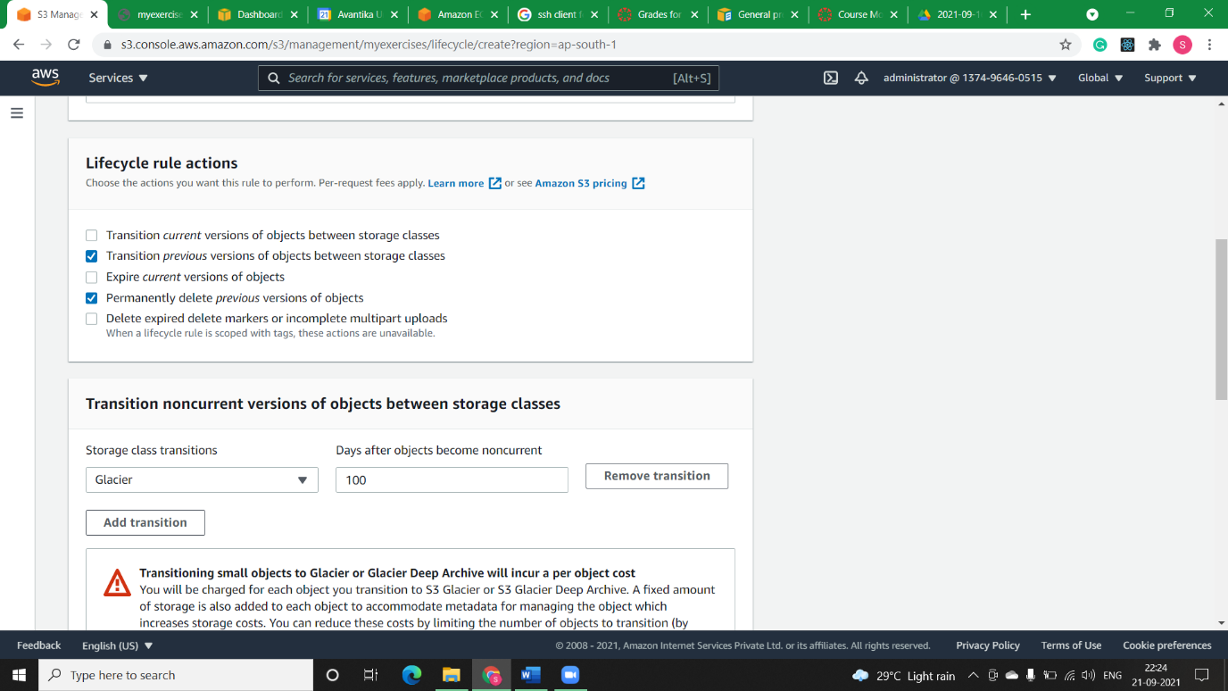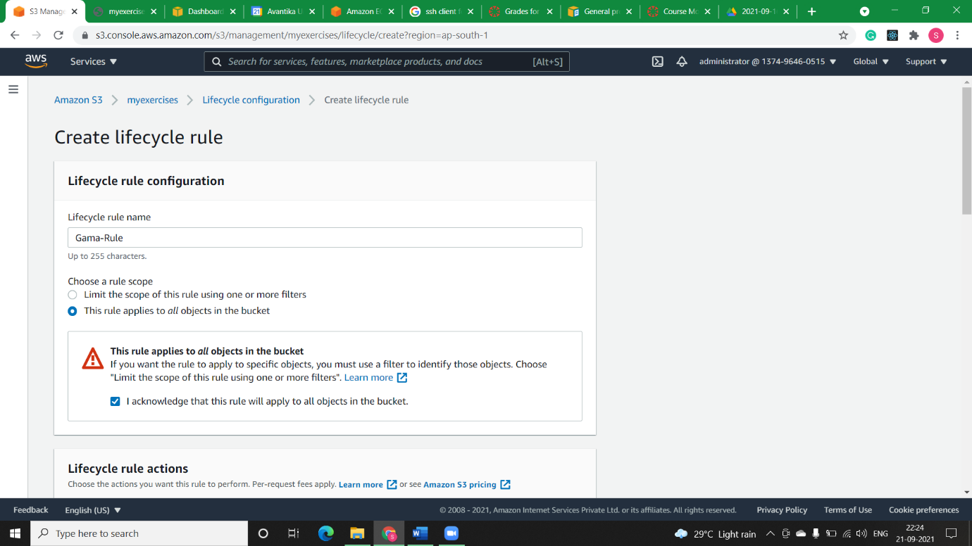

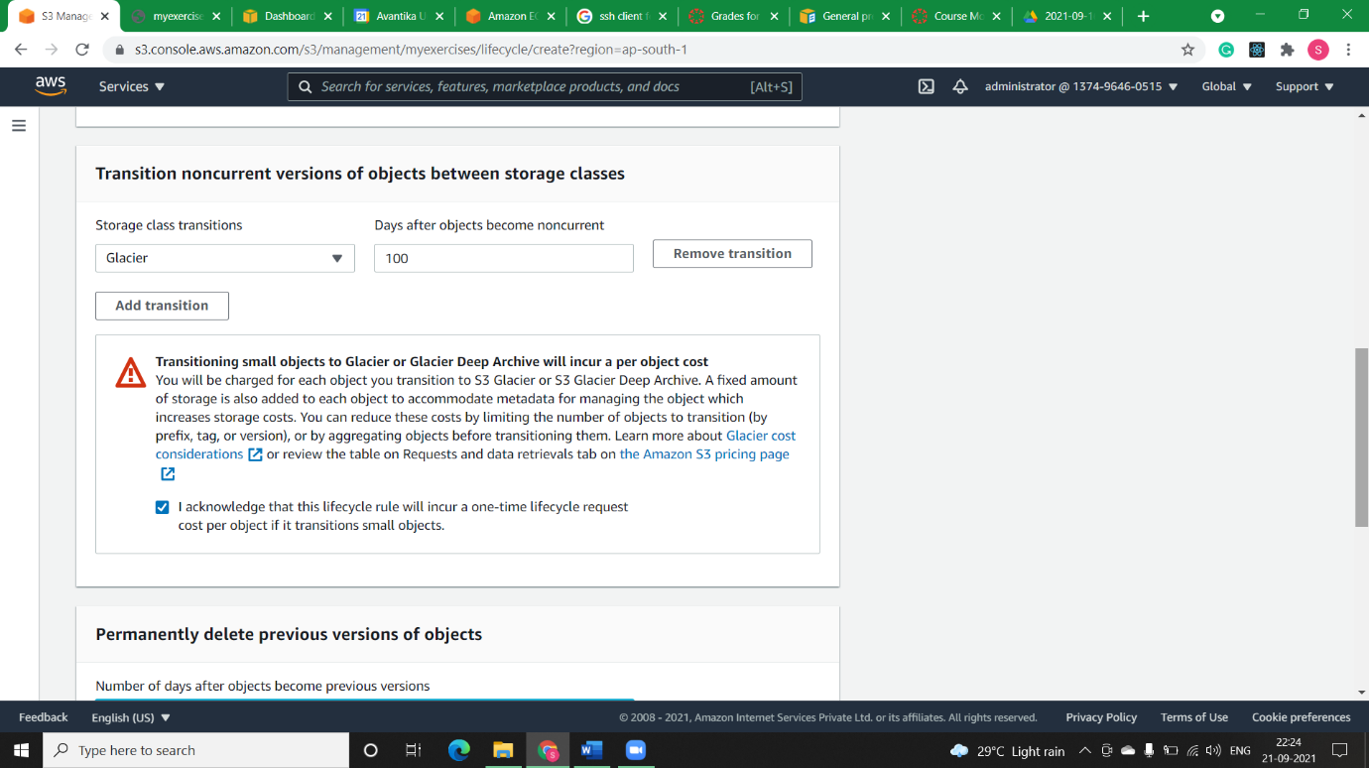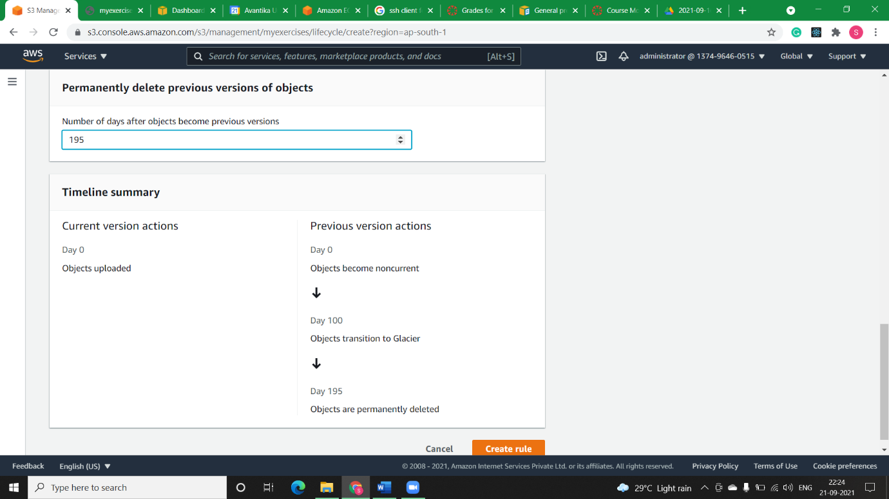

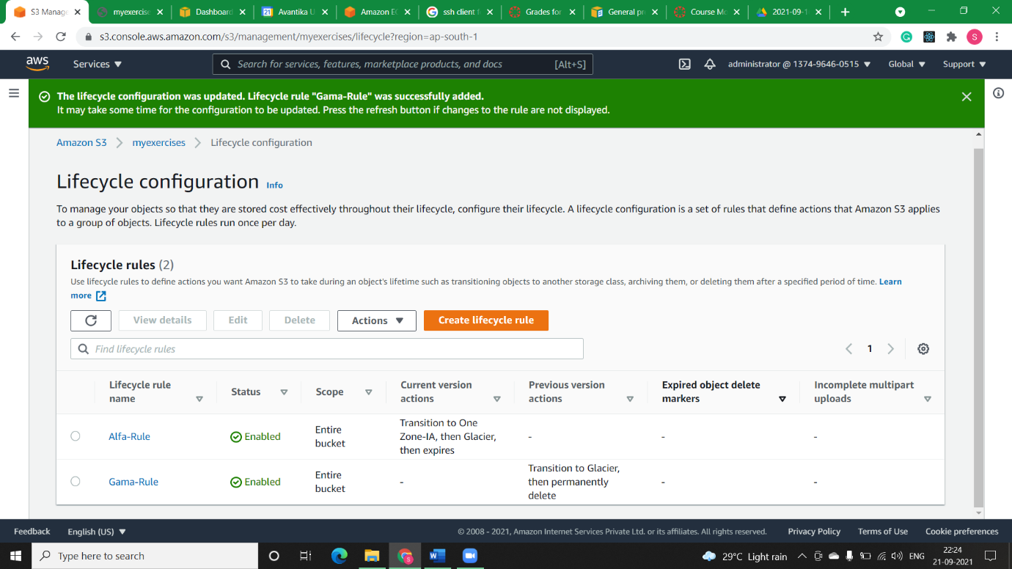

Note: We can see that the rule is successfully created with name Gama-Rule.